Mock CAT 2008
INSTRUCTIONS TO TEST TAKERS
* You are screwed
* The question paper and answer sheets have colours. Please co-ordinate at your centre with other aspirants to find the matching color corresponding to the question paper.
*This will test your team playing skills
*Each question has about 5 options, and the options are jumbled.
Example: - a) c) d) e) b) or c) e) b) d) a) the alphabets need not be a-e. They may be encrypted, Z might correspond to a, Y might correspond to b and so on…
* Each question has multiple answers.
Marking scheme
- Each correct answer has + 0.125/0.3
-Each incorrect answer has -20
- Each unattempted question has –(3*x) where x is remainder obtained when 4^{y} is divided by the numerical value of question number and y is log₄(question number)
No calculators are allowed. Each centre has 10 log tables hidden somewhere. Please co-ordinate with everyone to find and use it. Each logbook is in a different language. You may find bonus questions in the log book.
Marking scheme for bonus questions.
- Each correct answer has + 0.127/0.29
-Each incorrect answer has -19.9
- Each unattempted question has – (4*x) where x is remainder obtained when 3^{y} is divided by the numerical value of question number and y is log₃(question number)

There are 20,000 questions, 4 sections.
- Problem Solving
- Logical Reasoning
- Verbal abilities
- Bonus questions
Time allotted – 30 minutes
It is necessary to solve at least 10,000 correctly for your CAT score to be considered for the IIMS.
Do not write ANYTHING on the OMR no matter how much we prompt you during the course of the exam.
Good luck.

Problem Solving
- Complete the sequence 14,22,xyz, 356h, -0.234,……..
e) all of the below
c) 1
b) integral f(x) dx. From limits -20 to 20 where f(x) = 0 from -20 to 0 and -0 from 0 to 20
a) b or c
d) none of the above

- Find the area of the figure using the data given in the figure.

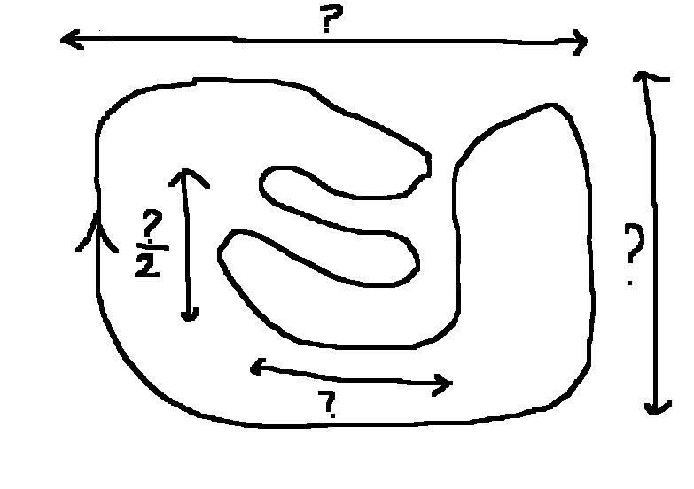
- constant
- depends
- (a)+(b)/2
- ?/2 * ?
- 0.25

- If I think of a number, what is the probability that it is 3,45,275.2345
z) Infymax
r) delta
p) 1/infy
j) 1/3,45,275.2345
f) 3,45,275.2345
4) 2 trains are going somewhere. T1 is between Chandigarh and Ludhiana. T2 is between NY and Ohio. In how much time will they cross each other?
Assume speed of T2 = mach3, length of T1= 2 km, and difference in time zone = 11 hours. The train leaves Chandigarh at 3 past midnight Singapore time. T2 leaves NY at 2 pm Moscow time. For Singapore and Moscow timezones, refer to your mobile phones (remember:- use of mobile phones is not permitted) .
Speed of T1 = |∑Ω☺βψ√,,|,,↔|* Speed of T2 where all symbols have their usual mathematical meanings. Length of T2 = 4 times the area of your CAT question paper in square microns, neglecting the header and footer.
a) insufficient information
d) extra information
c) 2 seconds (please prove it in the margin of your OMR)
d) option e)
e) option d)

- 4 runners start a race, Appa, Bappa, Chappa and Dappa. Appa gives Chappa a start of 2 mins. But , Bappa gives Dappa a start of 50 mt. Then 15 min into the race, Dappa overtakes Appa, then 5 min later, Appa overtakes Dappa and so on… But after 10 min, bappa sees that Appa has a lead of 15 min, but chappa trails appa by 100 mts. Appa then stops till chappa overtakes dappa. Then appa starts and bappa stops till dappa overtakes chappa again. At this point chappa falls down and waits for first aid. The first aid had a start of 20 mins in the beginning but it later lost ground and it had to cover up 3 kms before it came to the aid of chappa. Meanwhile, When appa increased his speed 1.245 times and just overtook bappa, then bappa had to increase speed 3 fold to overtake dappa who had increased his speed by 2/3 times. Then chappa also starts running, and increases his speed 8 .667 fold to overtake dappa. At this instant if all reverted back to their original speeds, it would be noticed in the next 15 minutes that, Appa had a lead of 200 mt over dappa, Dappa had a lead of 200 mt over Bappa, Bappa a lead of 200 mt over chappa and chappa alead of 200 mt over appa. The distances covered by appa is the average of that covered by bappa and chappa in their normal speeds at 36 degree C. But Dappa covers twice of half of one third of that covered by appa in 72 Degrees. So find the temperature at which they were running. Assume the speeds to be constant.
x) 37C
b) 98F
n) 300K
4) One cannot run at the temperature they were running
o) Depends on the speed of the first aid

Logical Reasoning and data interpretation
Answer the questions based on the graphs shown below.
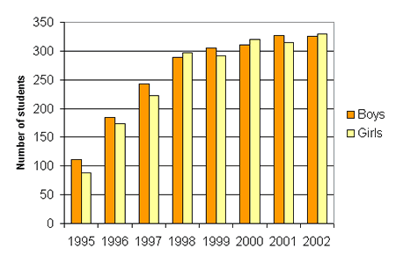 | 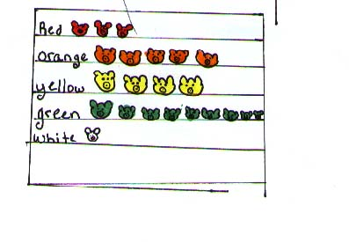 | 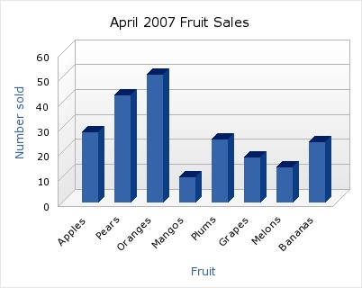
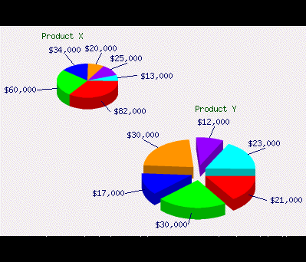 | 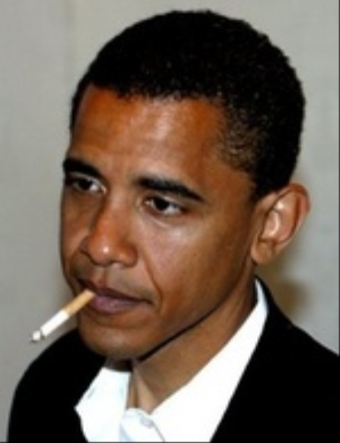 | 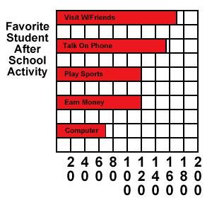
 |  | 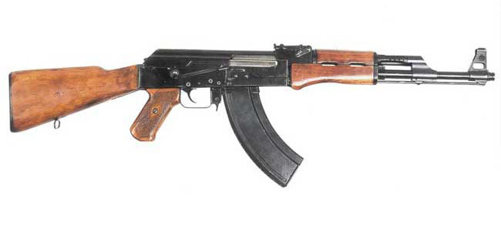
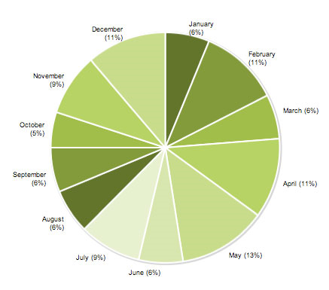 | 



Q1 ) Is Britney Innocent?
- Does this face lie to you??
- Hit me baby one more time
- Oops I did it again
- As innocent as fruit sales in january in the graphs above
- Is Osama also innocent??
Q2) What is the profit of company z?
d) sales of company x – cost of company y
f) AK 47
s) Yes we can!
Q) Number of green teddy bears – number of orange teddy bears
q) Is Michael Jackson innocent? 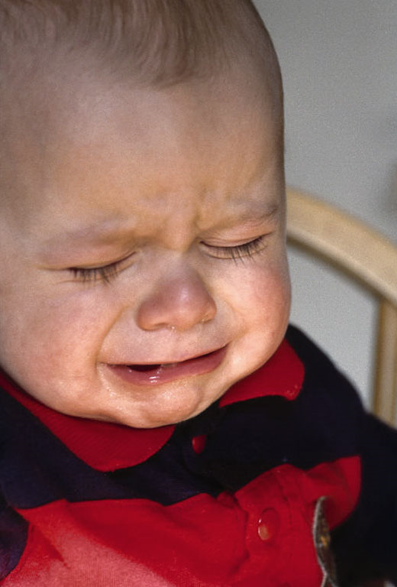
Q3) What is the length of obama’s cigarette?
3)
344)
5483)
32)
0)

(note:- the option number indicates the answer)

- From figure 4 and 5: how many votes did Mccain get?
(for the options, please refer to the log book)

- What is the favourite student afterschool activity?
u) Depends on second last graph
c) Depends on last graph
f) Option 3 of Q1 in section 3 – Option 1 of Q3 in section 1
k) wwf
u) pokemon/digimon

Verbal abilities
Answer the qweshan based aan dha passage belaw.
NOTICES:"HEY YOU ALL PEOPLE IN THE ORKUT.BOY GALS AND EVERYBODY IN ORKUT.MY WARNING IS THAT PLAESE NOT ADD ME EVERYBODY.I HAVE MANY WORKS TO DO.EMAIL ME IF YOU WANT ME ADD.BUT EVERY PEOPLE NOT ADD ME TAKE MY PERMISSION.AND ONLY GOOD PEOPLE ADD ME NO BAD."NAZIM SAYS.
hey hi boys girls and evrybody
im a nice guy
i want great frandship frm all boys and girls
i looking for my queen basically
i can be a very good fradship ...because im nice
evryone add me so dat frandship growth..so frands for ever
im smart evryone likes me ...i very open so ppl add me very quick ...they think i very nice
SO GALS wat u waiting for
add me on nazim_hakeem@hotmail.com
anybody need advise on love topics plz tell me i romantic and i know abt love very much so plzzz add me and tell i about your love problems i always ready to help girls only.i love very well to all gals n womens.i make good lov from every1 and friendship also.i play computer very good,play hockey,cricket and sports and all sports n games.AND!!!! i best player of love n friendship from gals n womens so wat u think of I u can scrap me everytime and anytime and talk me anything
HEY U ALL ORKUT PERSONS.WOMAN,MAN GALS & BOYS AND EVERYONE IN ORKUT.NAZIM SAY LOVSHIP AND FRIANDSHIP TO ALL.I JOIN ORKUT FOR SOLVE ALL GIRLS AND MANS LOVESHIP AND FRIANDSHIP PROBLEMS. I WANT LOVSHIP AND FRIANDSHIP GROWTH.ALL PERSONS JOIN MASTER NAZIM COMMUNITY AND SAY YOUR PROBLEM PROPERLY.I HELP GIRLS AND WOMENS BUT BOYS ALSO.JOIN2DAY AND SAY NAZIM YOUR PROBLEM.I ANSWER YOUR SAYINGS HERE.NAZIM BEST PLAYER OF LOVESHIP NAD FRIANDSHIP SO ALL U COME THEN AND JOIN ALSO.ALL PROBLEMS NAZIM SOLVES.LOVESHIP & FRIANDHIP FOR ALL, MESSAGE OF NAZIM.I COME TO SOLVE YOUR PROBLEMS AND SAY MESSAGE OF LIVSHIP AND FRIANDSHIP ALSO.I SAY TRUTHFUL SAYINGS OF YOUR PROBLEM.NOT GO TO FALSE SAYINGS PERSONS.COME FOR NAZIM HAKEEM.NASIM MASTER OF LOVESHIP AND FRIANDSHIP AND ROMANCE ALSO
NOTE:"NO BAD TALKS HERE.ONLY PROPER TALK OF LOVESHIP AND ROMANCE AND FRIANDSHIP ALSO".
SAY ALL QUESTIONS OF LOVSHIP AND FRIANDSHIP AND MARRIGING PROBLEMS ALSO IN LOVE.I SOLVE EVERYTHING AND EVERY TYPE PROBLEMS.
LOVSHIP FOR ALL
- Haaw many caaraactaars besings in the above notices than??
a) dontknowship
z) too maach countering involveship than
b) luvship and friandship naat knowsing boundfuls
y) wonly nazim maans knowerings than
™) its secretship than!!
- Who solvering aal ur praablem then??
a-e) Nazim man ( marking wraang answer will result in cancellation aaf ur aaplication, so choose carefulshipsly than…)
- who besings the maan than??
- shahrukh khan
- hritik roshan
- james bond
- yaars truely
- manbearpig

- What typeship talkering not besings allowedful than??
- luvship
- friandship
- bothship
- goodful talkering
- bad

